**6.7 Inverse Relations and Functions**.  
Objective: To find the inverse of a relation or function

**Inverse Relation**: maps the output values back to the original input values (x’s and y’s switch)

* The domain of the inverse relation is the range of the original relation, and the range of the inverse relation is the domain of the original relation

Original Relation Inverse Relation

|  |  |  |  |  |  |  |  |  |  |  |  |  |
| --- | --- | --- | --- | --- | --- | --- | --- | --- | --- | --- | --- | --- |
| x | -2 | -1 | 0 | 1 | 2 |  | x |  |  |  |  |  |
| y | 4 | 2 | 0 | - 2 | - 4 |  | y |  |  |  |  |  |

**Inverse Functions**: when the inverse and original relations are both functions, then they are inverse functions of each other

**Graphing Inverse Relations**;

Reverse the ordered pair and then graph.

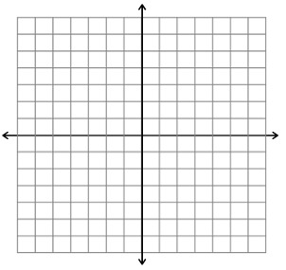

**Finding the Inverse Relation**;

1. Switch x and y in the original relation
2. Solve for y (if possible)

*Example:*

Find an equation for the inverse of the given relation:

y = 2x – 4 

**Inverse Functions**;

Functions f and g are inverses of each other provided:

**f(g(x)) = x and g(f(x)) = x**

*The function g is denoted by f-1, read as “f inverse”*

*Example:*

Verify that f and g are inverse functions:

f(x) = x + 7 and g(x) = x – 7

f(x) = 2x – 4 and 

**HMWK: page 409 #9-21 (odd), 37**